KALVIUM DATA ANALYST TASK

LOK SABHA ELECTION ANALYSIS:

**Introduction:**

Examining Lok Sabha elections using data analysis offers a strong foundation for comprehending the electoral dynamics and political environment of India. The Lok Sabha, consisting of 543 parliamentary constituencies, has a crucial influence on the formation of the nation's government and policies. The elections, overseen by the Election Commission of India (ECI), are a colossal undertaking that encompasses millions of voters, a variety of political parties, and intricate regional dynamics. Let us illustrate the insights from the URL given.

**Insights from the URL given:**

**No. of Parliamentary constituencies :**The total number of parliamentary constituencies is 543.

**State-Specific Assembly Constituencies :**  
There are 175 State-Specific Assembly Constituencies in Andhra Pradesh and 147 in Odisha.

**Bye Elections**: 25 Assembly Constituencies.

**Regional Participation**: Arunachal Pradesh and Sikkim.

**Remaining constituencies**:196.

**Representation of Total Parliamentary constituencies:**

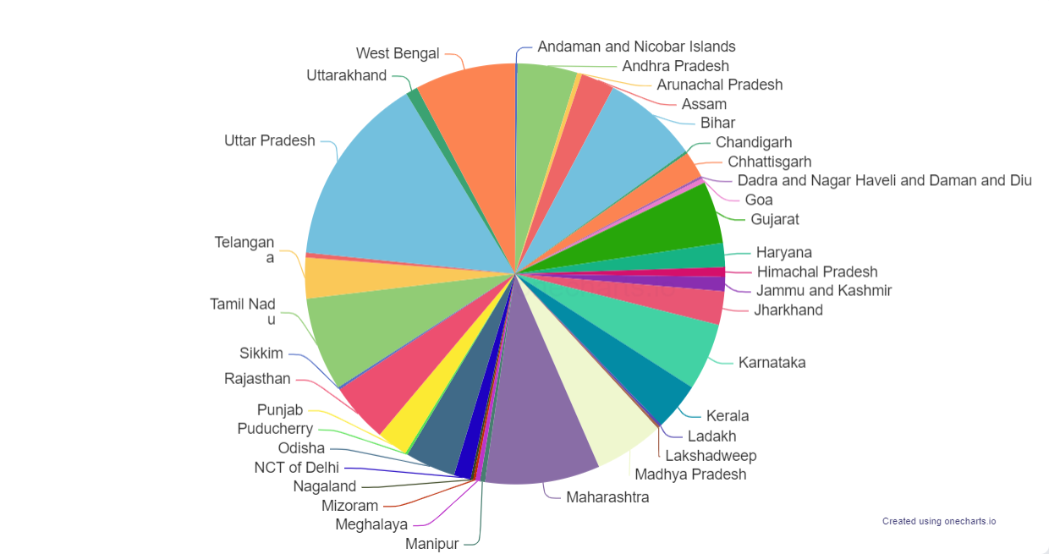

Python code:

import requests

from bs4 import BeautifulSoup

req = requests.get("https://results.eci.gov.in/")

soup = BeautifulSoup(req.content, "html.parser")

res = soup.title

print(soup.get_text())

**PARTY-WISE RESULTS:**

Party-wise results indicate the number of seats gained by each political party based on the available data.  
1.The Bharatiya Janata Party (BJP) won 240 seats.   
2.The Indian National Congress (INC) won a total of 99 seats.   
3.The Samajwadi Party (SP) won 37 seats.   
4.The All India Trinamool Congress (AITC) has won 29 seats.   
5.The Dravida Munnetra Kazhagam (DMK) won 22 seats.

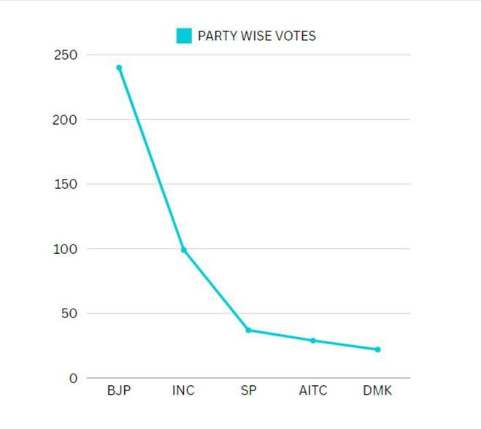

Python code:

import requests

from bs4 import BeautifulSoup

req = requests.get("https://results.eci.gov.in/PcResultGenJune2024/index.htm")

soup = BeautifulSoup(req.content, "html.parser")

res = soup.title

print(soup.get_text())

**Insight** :The Bharatiya Janata Party (BJP) has obtained the most number of seats, winning 240 out of the 543 parliamentary constituencies, while the Indian National Congress (INC) has earned 99 seats. The current election results show a substantial advantage for BJP.

**General Election to Assembly Constituencies: Trends & Results June-2024**

**Andhra Pradesh Assembly Constituencies**:

Total Assembly Constituencies: 175

Leading/Won Parties:

TDP: won 135 seats.

JnP: won 21 seats.

YSRCP: won 11 seats.

BJP: won 8 seats.

Insight: TDP won in Andhra Pradesh .

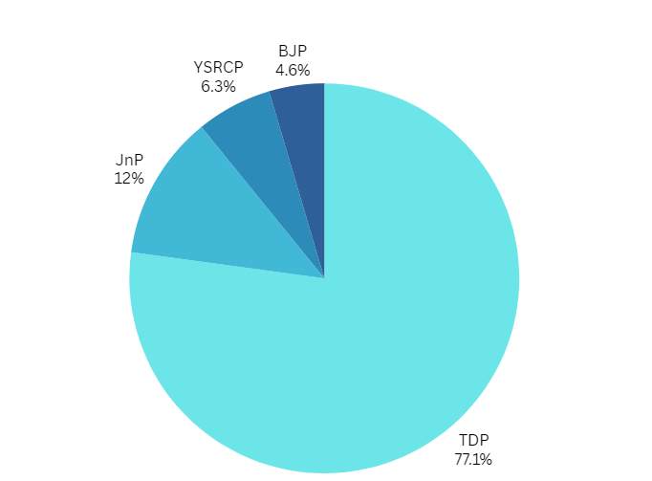

**Constituencies in the Odisha Assembly**:   
  
The total number of assembly constituencies is 147.

* The Bharatiya Janata Party (BJP) has won 78 seats, the Biju Janata Dal (BJD) has won 51 seats, the Indian National Congress (INC) has won 14 seats, independent candidates have won 3 seats, and the Communist Party of India (Marxist) (CPI(M)) has won 1 seat.

**TamilNadu Election Results:**

* The Dravida Munnetra Kazhagam (DMK) party has emerged victorious in 22 seats and is now leading in 0 seats, bringing their total tally to 22 seats.
* The Indian National Congress (INC) has emerged victorious in 9 seats and is currently leading in 0 seats, resulting in a total of 9 seats.
* Viduthalai Chiruthaigal Katchi (VCK) has emerged victorious in 2 seats and is currently leading in 0 seats, resulting in a total of 2 seats.
* The Communist Party of India (CPI) has secured victory in 2 seats and is currently leading in 0 seats, resulting in a total of 2 seats.
* The Communist Party of India (Marxist) - CPI(M) has secured victory in 2 seats and is currently leading in 0 seats, making a total of 2 seats.
* Marumalarchi Dravida The Munnetra Kazhagam - MDMK party has been victorious in 1 seat and is currently leading in 0 seats, making their total seat count 1.
* The Indian Union Muslim League (IUML) has won 1 seat and is currently leading in 0 seats, making a total of 1 seat.

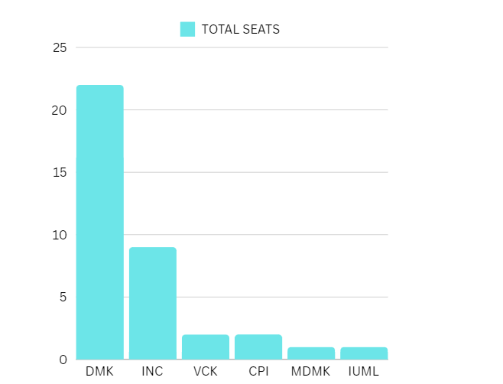

Insight: DMK won major seats in TamilNadu.

**Overview of Bye Elections**- The results encompass bye-elections conducted in several states

victorious parties and candidates from the bye-elections:

* **Bihar** : SHIV PRAKASH RANJAN from the Communist Party of India (Marxist-Leninist) emerged as the winner.
* **Gujarat:**
  + Dr. C. J. Chavda, representing the Bharatiya Janata Party, emerged as the victor in Vijapur.
  + Arjun Devabhai Modhwadia, representing the Bharatiya Janata Party, emerged as the victor in Porbandar.
  + The winner of the Manavadar constituency is Arvindbhai Jinabhai Ladani from the Bharatiya Janata Party.
  + Chiragkumar Arvindbhai Patel from the Bharatiya Janata Party was victorious in Khambhat.
  + Dharmendrasinh Vaghela (Bapu) from the Bharatiya Janata Party emerged as the winner in Vaghodia.
* **Haryana** : NAYAB SINGH emerged as the victorious candidate from the Bharatiya Janata Party.
* **Himachal Pradesh:**
  + DHARAMSHALA: SUDHIR SHARMA, a member of the Bharatiya Janata Party, emerged as the winner.
  + Anuradha Rana, a member of the Indian National Congress, emerged as the winner in the LAHAUL & SPITI constituency.
  + Captain Ranjit Singh from the Indian National Congress emerged as the victor in Sujanpur.
  + The winner of the BARSAR constituency is INDER DUTT LAKHANPAL from the Bharatiya Janata Party.
  + The winner of the GAGRET constituency is RAKESH KALIA from the Indian National Congress.
  + KUTLEHAR: VIVEK SHARMA (VICKU) emerged victorious as the candidate for the Indian National Congress.
* **Jharkhand:** Kalpana Murmu Soren from the Jharkhand Mukti Morcha emerged as the winner.
* **Karnataka** : RAJA VENUGOPAL NAIK from the Indian National Congress emerged as the winner.
* **Rajasthan** : JAIKRISHN PATEL, representing the Bharat Adivasi Party, emerged as the winner.
* **Tamil Nadu** :THARAHAI CUTHBERT, representing the Indian National Congress, emerged as the winner.
* **Telangana** : SRIGANESH from the Indian National Congress emerged as the winner.
* **Tripura**: DIPAK MAJUMDER emerged as the victor for the Bharatiya Janata Party.
* These results highlight the winning parties and candidates from the bye-elections across various constituencies.

**10 Insights from these data extracted:**

* BJP's Electoral Supremacy: The Bharatiya Janata Party (BJP) established itself as the dominant political party in the General Elections to Parliamentary Constituencies, capturing 240 out of 543 seats, thereby demonstrating its substantial electoral prowess across the country.
* Congress Performance: The Indian National Congress (INC) secured 99 seats in the parliamentary elections, indicating its status as a significant opposition party. However, this also underscores the difficulties it faces in expanding its support among voters.
* Regional parties such as the Dravida Munnetra Kazhagam (DMK) in Tamil Nadu and the Trinamool Congress (AITC) in West Bengal demonstrated significant success by winning 22 and 29 seats respectively, highlighting their considerable regional influence.
* State-Specific Assembly Strength: Andhra Pradesh has a total of 175 State Assembly Constituencies, whereas Odisha has 147, demonstrating a substantial level of electoral engagement and political representation at the state level in these areas.
* Bye-elections in several states, including Bihar, Gujarat, Haryana, Himachal Pradesh, Jharkhand, Karnataka, Rajasthan, Tamil Nadu, Telangana, and Tripura, have had a significant impact on the political landscape. The BJP and other parties have emerged victorious in multiple contests, hence changing the local political dynamics.
* Distribution of State Wins by Party: The Bharatiya Janata Party (BJP) earned victory in 78 seats in Odisha, while the Biju Janata Dal (BJD) won 51 seats. The Indian National Congress (INC) managed to secure 14 seats, with 3 seats going to independent candidates and 1 seat to the Communist Party of India (Marxist) (CPI(M)). This demonstrates the presence of multiple political parties in the state legislature.
* In Tamil Nadu, the DMK won 22 seats, the INC won 9 seats, while smaller parties such as Viduthalai Chiruthaigal Katchi (VCK), CPI, and CPI(M) each got 2 seats. This demonstrates a diverse and multi-party competition in the region.
* Successful Candidates: Prominent victors include politicians such as Arjun Devabhai Modhwadia (BJP) in Porbandar, Sudhir Sharma (BJP) in Dharamshala, and Kalpana Murmu Soren (JMM) in Jharkhand, highlighting the varied political leadership found across different states.
* Arunachal Pradesh and Sikkim actively participated in the electoral process, thereby enhancing the diversity of regional political representation in the parliament.
* The election results demonstrate how voter opinions are influenced by local concerns and the agendas of regional political parties, which in turn shape the political environment at both the state and national levels.

**Conclusion:**

Therefore, the URL has been scraped and the data has been taken. Based on the retrieved data, 10 insights have been depicted and delineated.